Welcome to the Connect 4 championship.

On this side we have ME – the red team – going head to head against the computer.

Relying on my fantastic wealth of experience, I chose to go here.

Which was really hard to capture on a screen shot because the computer made a very fast move and went…

Which was probably as good an opening move as I made.
I have decided not to capture each individual move from now on, instead I will capture moves in pairs.

I decided to be tricky and start building my way up.

And the computer decided to repeat the favor.

I couldn’t have that – so I decided to block it’s maneuver.

In a fit of stupidity – the computer decided to take the next move on the same access anyway.

So I continued to build my own column

.

Which the computer deftly blocks.

Now I have to try another tack…

Which hasn’t really improved things much. There are only 2 ways I can win now – 3 for the computer. Maybe I’m not as smart as I thought.

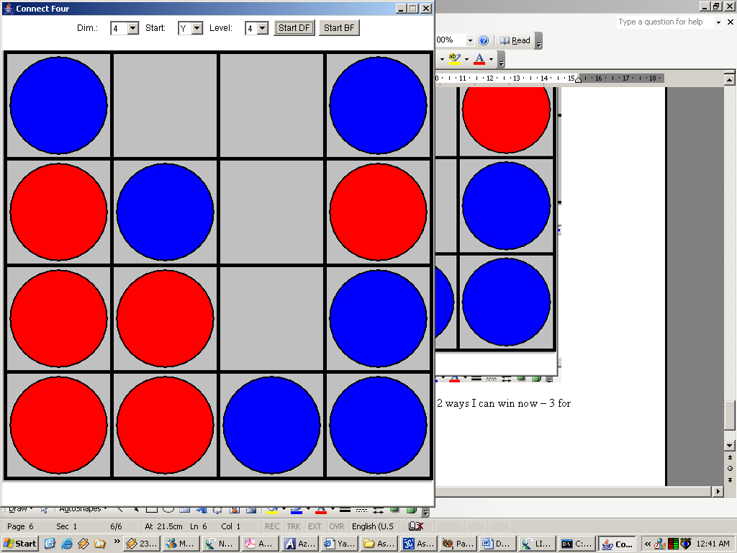
In case anyone is wondering why there is a board behind this one
It is this document, I was writing it as I took the screenshots

ARRGGHHH – my next move was fine – but the reply from the computer has totally destroyed my changes of winning. I can’t win now – it’s just impossible.

But I continue on, hoping to at least gain a draw.

I block the computer’s winning move, and now neither of us can win – ah well, such is life.

And so now the board is full – and according to the lovely little message thing down the bottom of the game – it is a draw. What a pity.

Now just to prove it actually works – here is a picture of me:

Winning! ☺ | Getting Thrashed ☹

And just to prove it works on a bigger grid size as well.

NOTE: All screenshots were taken using computer players – with HUMAN_VS_COMPUTER=true

Also – they were taken from a mixture of Depth First and Breadth First games.

